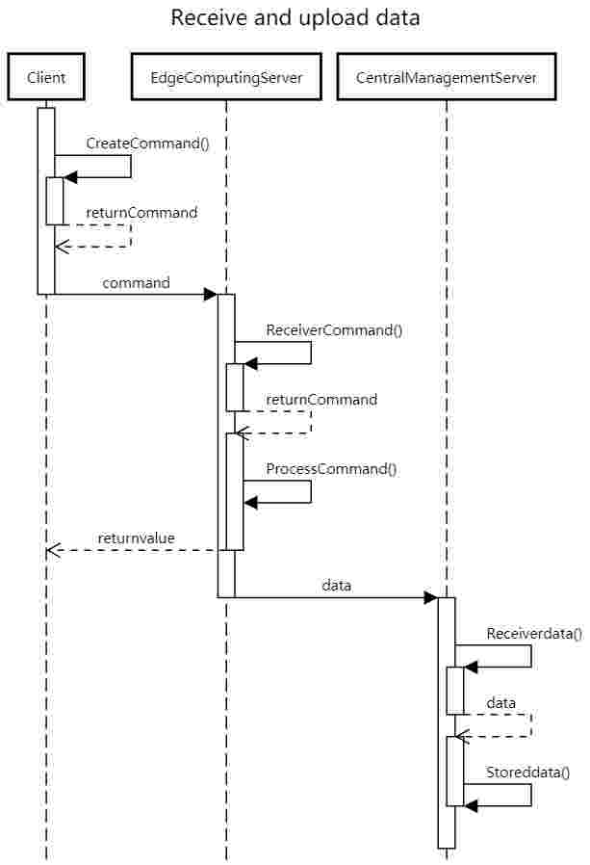

1. The client generates commands according to the user's needs
2. The client sends the command to the edge server
3. The edge server receives the command and processes the command
4. The edge server returns the data to the client
5. The edge server passes the data to the central server
6. The edge server passes the data to the central server